**Creating a Slack Incoming Webhook**

1. Go to <https://api.slack.com/apps> and click Create New App.

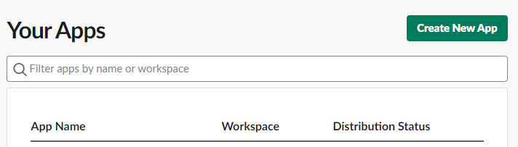

1. You can see a pop-up. Create an app from scratch.

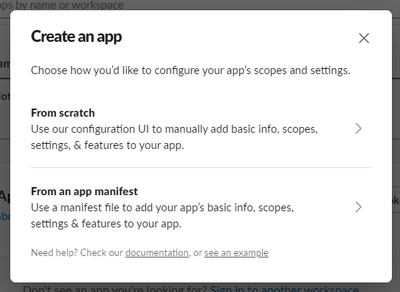

1. Enter your App name, for example, “Notification” and pick your slack workplace. Then click on Create App

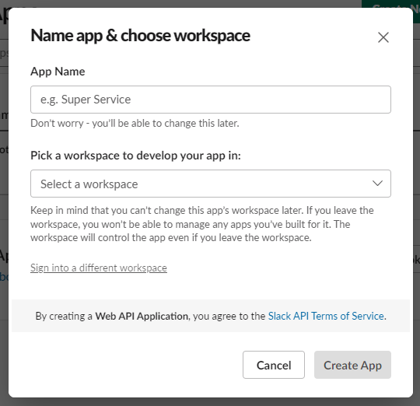

1. Choose Incoming Webhooks under Add features and functionality.

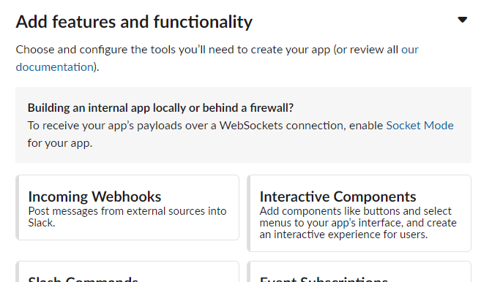

1. Activate Incoming Webhooks

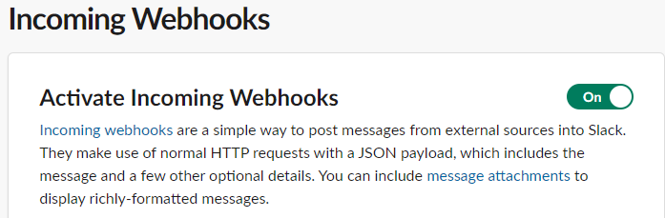

1. Click on Add New Webhook to Workspace.

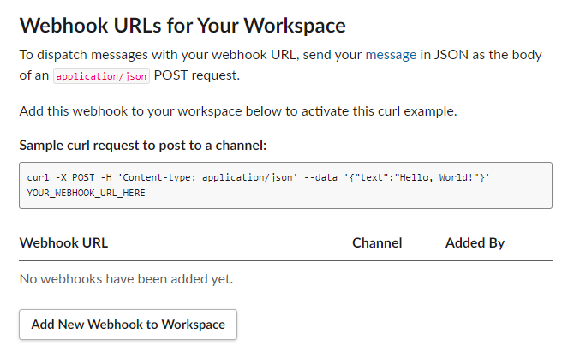

1. Select a channel from the drop down menu where you want to send notifications and then click Allow.

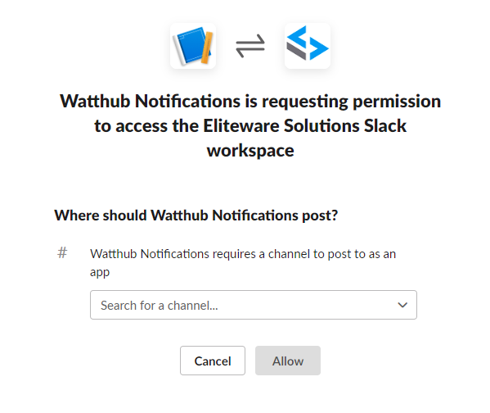

1. Copy Webhook URL.

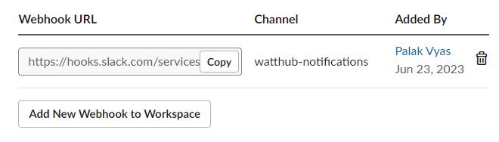

**Write a function to send notifications from Google Sheets to Slack**

1. Go to your Google Sheets and select Apps Script from the Extensions.

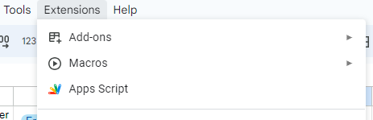

1. Copy the code from the file “sheets to slack” on <https://github.com/palakv213/WorkflowAutomation.git> to the Apps Script code.gs
2. Edit the code as instructed in the comments of the code and save it.
3. Go to Triggers from the left menu and click on Add Trigger.

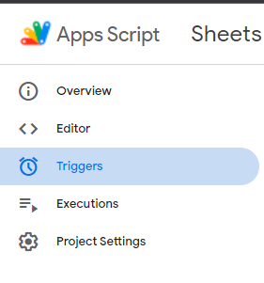

1. Select event type On edit and click Save.

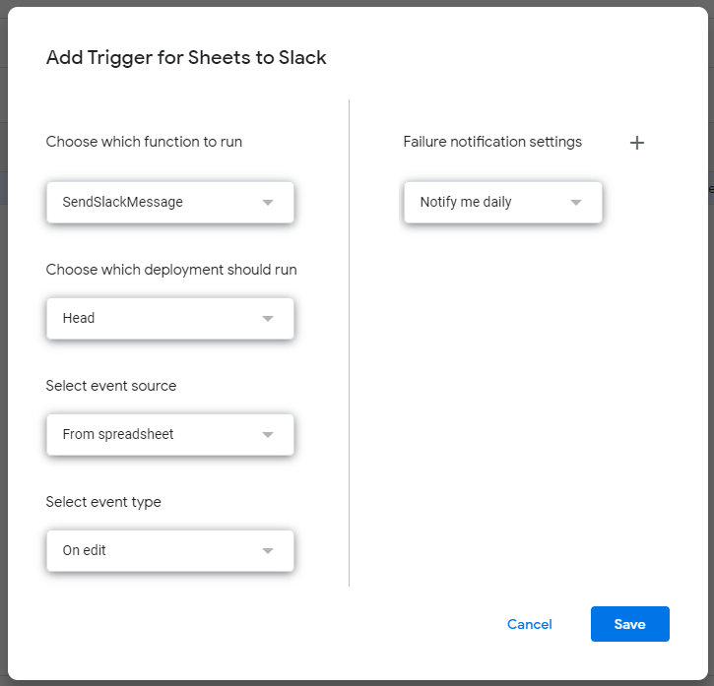

Make changes to your sheet and you will get the notification on Slack.